**IFT 266 Introduction to Network Information Communication Technology (ICT)   
  
Lab 24**

**Troubleshoot a VLSM network**

Co-authored by Chris Maness

1. 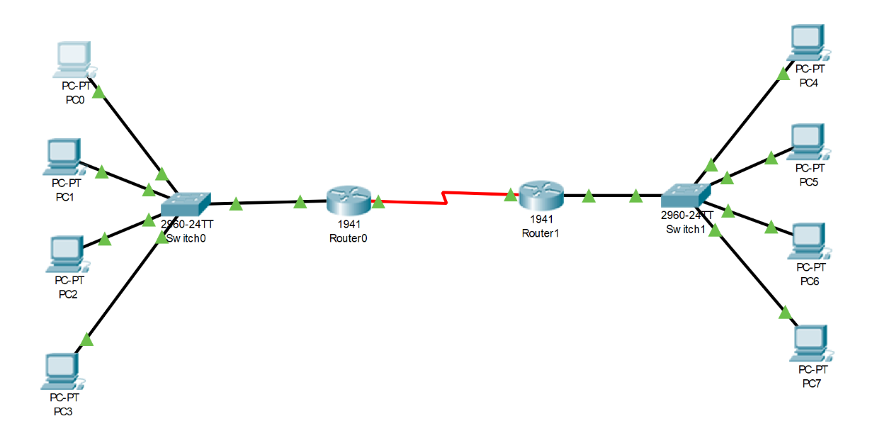Set up the following topology in Packet Tracer.   
     
   You will need to add one HWIC-2T to each router.





1. Configure Router0 with the following commands

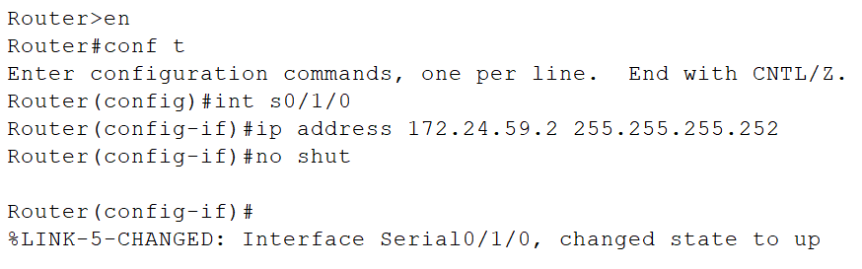

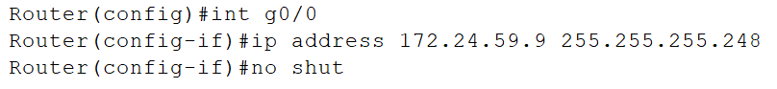



1. Repeat the same for configuration for Router1 but assign s0/1/0 an IP address of 172.24.59.1 and a subnet of 255.255.255.252 and assign g0/0 172.24.59.17 and a subnet of 255.255.255.248.



1. Assign PC0 an IP of 172.24.59.3 and a subnet of 255.255.255.252. What error does Packet Tracer give? and why does it give the error (be specific as to why you get the error and cannot assign this address)?

The error you receive is an invalid subnet mask for this IP address. This is because we configured the subnet mask for the g0/0 interface with 255.255.255.248. 255.255.255.252 is the subnet mask between the routers. Also this subnet is only valid for 4 addresses, .1 and .2 are assigned to the routers, .0 is the network address and .3 is the broadcast address. Therefore, there are also no more IP addresses available within this subnet.

1. Create an IP scheme that works for the subnet PC0 is on. The first address is given. The CIDR should be the same for all your addresses.

|  |  |  |
| --- | --- | --- |
| **Device** | **IP Address** | **CIDR (/X)** |
| PC0 | 172.24.59.10 | /29 |
| PC1 | 172.24.59.11 | /29 |
| PC2 | 172.24.59.12 | /29 |
| PC3 | 172.24.59.13 | /29 |

1. Assign PC4 the IP 172.24.59.16 and a subnet of 255.255.255.248. Why won’t Packet Tracer let you assign this IP (be specific as to why you get the error and cannot assign this address)?

Because this IP address is the network address for this configuration.

1. Assign PC4 the IP of 172.24.59.12 and the same subnet (255.255.255.248). Although Packet Tracer lets you assign the IP, this IP would be incorrect.   
     
   List **two reasons** why this IP would not work.

Subnet overlap – IP address 172.24.59.12 is within subnet 172.24.59.8/29 – which is outside the range we assigned (172.24.59.9 – 172.24.59.14)

Duplicate IP addresses – PC0 is already assigned 172.24.59.10 to 172.24.59.13 which are within 172.24.59.8/29.

1. Create an IP scheme like the one you made in Step 5, starting at PC4.

|  |  |
| --- | --- |
| **Device** | **IP Address** |
| PC4 | 172.24.59.18 |
| PC5 | 172.24.59.19 |
| PC6 | 172.24.59.20 |
| PC7 | 172.24.59.21 |

1. For the scheme you made in the previous step, list the broadcast address, the network address, and the range of usable hosts.

|  |
| --- |
| Broadcast Address – 172.24.59.16 |
| Network Address – 172.24.59.23 |
| Range of Hosts 172.24.59.17 – 172.24.59.22 |

1. PC 0 would like to be able to ping PC 4 and vice versa.

With the current network configurations, will this ping be successful? ______No____  
  
If not, why not? _We have not configured all the settings, such as default gateway__

**Important**

Please make sure to save your packet tracer file as you will need it for lab 25.